Kinematics Review Quiz Multiple Choice Questions

1. Which of the following are VECTOR quantities?
I. position II. speed III. displacement IV. velocity
a. I and III only d. II, III and IV only
b. III and IV only e. I, III and IV only
c. I and IV only

2. Which of the following graph(s) does(do) NOT represent uniform motion?
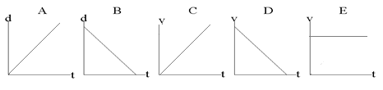

a. | A,B,C and D | d. | A and B
b. | B only | e. | C and D
c. | E only

3. The area under a velocity-time graph represents
a. | displacement | d. | instantaneous velocity
b. | acceleration | e. | average velocity
c. | change in velocity

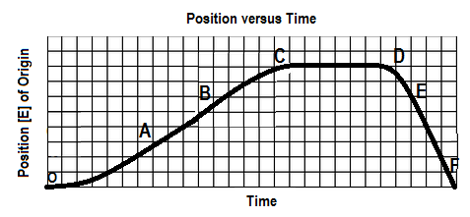
4. The graph below shows a position-time graph

Over which interval is the object moving west and speeding up?
a. OA b. BC c.CD d. DE e.EF

5. Two hikers set out from the same spot and arrive at the same destination but they take different routes. Which of the following quantities must be the same for both hikers?
a. | displacement | d. | average speed
b. | distance | e. | acceleration
c. | average velocity

6. The slope of a line drawn tangent to a curved position-time graph represents
a. | displacement | d. | acceleration
b. | instantaneous velocity | e. | distance
c. | average velocity

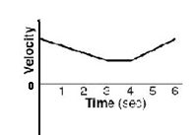
7. A velocity-time graph is shown at below. Which of following best describes the object’s motion? The object

a. moves backward at a constant velocity, stops, then moves forward at constant velocity.
b. moves forward at a constant velocity, stops, then moves backward at constant velocity
c. slows down uniformly as it moves backward, stops, then speeds up uniformly as it moves forward
d. slows down uniformly as it moves forward, continues at a constant velocity forward, then speeds up
uniformly as it continues to move forward
e. slows down uniformly as it moves backward, continues at a constant velocity backward, then speeds
up uniformly as it moves forward

8. An object is travelling west and slowing down. The directions associated with the
object’s velocity and acceleration, respectively, are:
a. [W], [W] b. [W], [S] c. [W], [N] d. [E], [W] e. [W], [E]

9. Drivers must always react to changing conditions on the road around them. What happens during
the reaction time, when a driver sees an obstacle on the road ahead?
a. The car immediately begins to slow down uniformly as the driver applies the brakes.
b. The car continues in uniform motion forward as the driver has not yet applied the brakes.
c. The car immediately stops as the driver applies the brakes.
d. The car speeds up momentarily as the driver experiences a surge of adrenalin and unconsciously
increases pressure on the gas pedal.

10. You are solving a “chase problem” between two moving objects in which you are determining the
point in time and space where the objects meet. Your analysis may include:
I. Finding the intersection point of the two curves on a velocity-time graph
II. Finding the intersection of the two curves on a position-time graph
III. Solving for time and displacement from the two displacement-time equations
- I only b. II only c. I, II and III d. I and III only e. II and III only

.

SPH4U0-Sep 2014 Kinematics Review Quest- Name:_________________
Total: _________/48 marks [K/U]
Useful Equations and Constants:
v_{av} =ΔΔ a =ΔΔ = Δ Δd= ½ (v₁+v₂) Δt Δd=v₂ Δt – ½ a (Δt)²
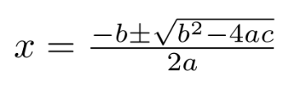
Δd=v₁ Δt + ½ a (Δt)² Δd = $\frac{v22-v12}{2a}$ g=9.80 m/s² [down]

Part A: Multiple Choice Answers [ 10 marks]:
Write the letter representing the best answer for each question in the table below:
1 | 2 | 3 | 4 | 5 | 6 | 7 | 8 | 9 | 10

Part B: Short Answer and Problem Solving [ 38 marks]:

1. A student explains that an object that has negative acceleration must be slowing down. Explain whether the statement is correct. Give an example to support your answer. [2]

2. A curling stone travelling at 6.00 m/s [N] hits a patch of rough ice 3.00 m in width. After passing over the rough patch it’s velocity has been reduced to 3.50 m/s [N]. Find the acceleration of the stone as it travelled over the rough ice. [4]

3. A car approaches an intersection with a constant velocity of 70 km/h [E]. When the car is 50m from the intersection the light changes to red. If it take the driver 0.2s to applying the brakes, and the car stops in 4.7 seconds.
- Sketch graphs of the car’s position and velocity as a function of time. [2]

Position
[West of stop light]
Velocity
[West]

Time

Time

- Determine if the car will stop before the intersection. [5]

4. Mr. Shaw tosses a ball in the air with an initial velocity of 12.0 m/s [up]. The ball rises to a peak height and then fall backs down into his hand. Ignoring air resistance determine:
a) The peak height the ball reaches. [3]
b) The time to reach the peak height. [3]
c) The time(s) at which the ball passes through a height of 2.00 m. [3]

5. The hare and tortoise are running a race! The lazy hare decides to give the tortoise a head start and watches from the start line as the tortoise pulls away running at a constant velocity of 1.50 m/s [F]. After 30.0 seconds, the hare takes off after the tortoise, accelerating at a constant rate of 0.750 m/s² [F]. Determine the distance and time at which the hare catches the tortoise. If the race is only 100.0 m long, who wins? [5]

Part C: Graph Analysis [11 marks]

1. The motion of a train engine moving along a straight track in a railyard is shown on the velocity-time
graph below.
i) Draw the corresponding acceleration-tine graph for the train. [3]
ii) Assuming that the train starts at the station (origin), draw the corresponding
position-time graph. [6]

Position-Time Graph:

Velocity-Time Graph:
8

4

0

-4

-8

V
(m/s)

[E]
Time
(s)
 | 1.0 |  | 2.0 |  | 3.0 |  | 4.0 |  | 5.0 |  | 6.0 |  | 7.0 |  | 8.0 |  | 9.0 |  | 10.0

Acceleration-Time Graph:

Describe the motion of the train: [2]

